MDG with AI – Demo
System: S23
Existing BP in S23-120?
Business Partner Number: 1000040
BearingPoint GmbH, Speicherstraße 1, 60327 Frankfurt am Main, DE811218846

Process:
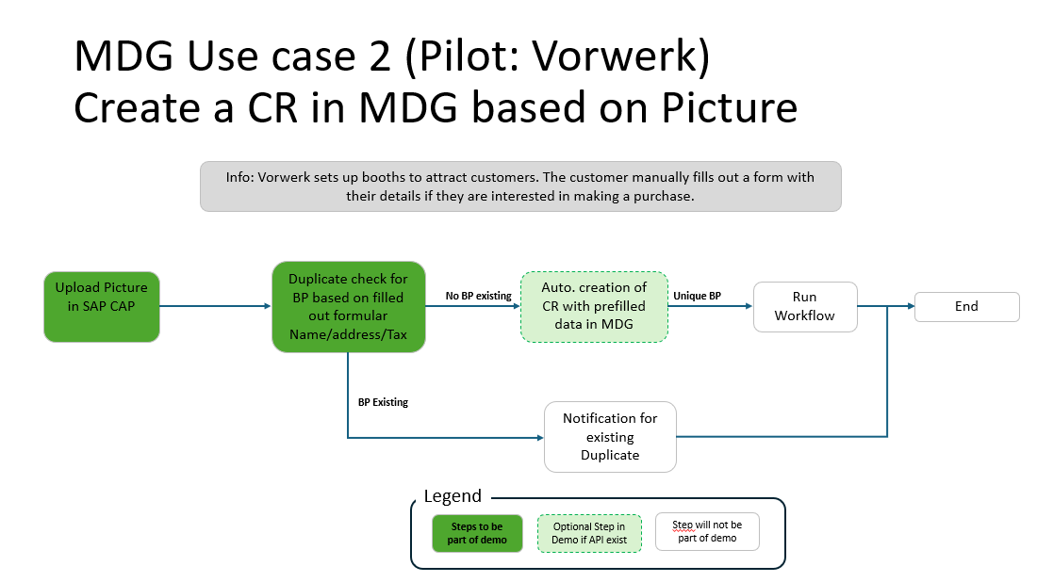

Summar:
A use case should be demoed for the utilization of AI in combination with MDG. The idea of the use case is to upload an image into SAP that contains information about a business partner. This information should be checked in the database for existence. If the business partner does not exist in the system, a change request in MDG should be initiated with the derived data from the image.
Process Description:
Upload Picture in SAP CAP:
In the first step of the process, there is a manual step performed by an SAP user. This user has a completed form with customer data (name and address). The SAP user takes a picture of this completed form and uploads it into SAP CAP.
Duplicate check for BP base on filled out formular Name/Adress/Tax:
This step is a technical step executed by AI. The image is read with the contained information. Using this information, the AI checks whether the business partner already exists in the system (Duplicate Check). For this purpose, the tables BUT000 (for NAME), ADRC (for Address), and DFKKBPTAXNUM (for Tax) should be evaluated. A duplicate is present with the following results:
- name and address are identical, or
- tax number matches.
In both cases the BP exists and the next step should be “Notification for existing Duplicate”.
If there is no Match for search criteria then no BP exists for this customer and a CR should be created in SAP MDG. Nex step ist then “Auto. creation of CR with prefilled data in MDG”.

Auto. creation of CR with prefilled data in MDG:
A CR should be create automatically in MDG, when the BP is not existing yet. The existing data Name, address and Tax number should be derived automatically from the picture into the Change Request.

